

Project Interim Report

On

Automatic Teller Machine Simulation

(Using Core Java & OOP Concepts)
RU-100-01-00012
Object Oriented Programming with Java

SESSION: 2025-26

Submitted By
Sahil Khan
ERP :- 11244

Bachelor of Technology in Computer Science & Engineering in association with Google

Under the Guidance of Mr. Ashish Shivhare

SCHOOL OF COMPUTER SCIENCE AND ENGINEERING RUNGTA INTERNATIONAL SKILLS UNIVERSITY
BHILAI, CG

(April 2026)

Abstract
The Automated Teller Machine (ATM) Simulation project is a console-based application developed using Object-Oriented Programming (OOP) principles. The main objective of this project is to replicate the basic functionalities of a real-world ATM system in a simplified and structured manner. It is designed to help users perform essential banking operations such as authentication, balance inquiry, and cash withdrawal.

This project is important because it provides a practical understanding of how secure banking systems operate while reinforcing core programming concepts. It demonstrates the use of classes and objects to model real-life entities like ATM and Account, ensuring modular and organized code structure. Encapsulation is applied to protect sensitive data such as account balance, while a static PIN is used for user authentication.

Additionally, the system incorporates exception handling to manage errors like invalid input, incorrect PIN, and insufficient balance, preventing program crashes. Through an interactive menu-driven interface, users can perform operations seamlessly. Overall, this project enhances problem-solving skills and provides hands-on experience in designing secure and efficient software systems using Java.

Introduction
The Automated Teller Machine (ATM) Simulation project is a detailed implementation of a basic banking system using Object-Oriented Programming (OOP) concepts in Java. The project is designed to simulate the working of a real ATM, allowing users to perform essential banking operations such as secure login, balance inquiry, and cash withdrawal through an interactive console interface.

In today’s digital world, ATMs play a crucial role in providing quick and secure access to banking services without requiring human intervention. This project is developed to understand how such systems work internally and to apply programming concepts in a real-world scenario. It focuses on creating a structured and modular system by dividing functionalities into different classes such as ATM and Account. The ATM class handles user interaction and authentication using a static PIN, while the Account class manages sensitive data like balance using encapsulation.

The project also emphasizes secure data handling and robustness. Exception handling mechanisms are implemented to deal with invalid inputs, incorrect PIN entries, and insufficient balance conditions, ensuring that the program does not crash and provides meaningful error messages. A loop-based menu system is used to make the application interactive and user-friendly.

Features of the Project
- Secure user authentication using a PIN
- Withdrawal of money with proper validation
- Balance checking functionality
- Encapsulation to protect account data
- Exception handling for error management
- Menu-driven interactive interface

Objectives of the Project
- Simulate real-world ATM operations
- Provide secure access to banking functionalities
- Reduce manual banking processes through automation
- Implement and understand core OOP concepts (classes, objects, encapsulation, etc.)
- Improve logical thinking and problem-solving skills through practical implementation

This project serves as a strong foundation for understanding larger banking systems and helps students gain hands-on experience in designing efficient, secure, and user-friendly applications.

Scope
The ATM Simulation project is designed as a basic and scalable system suitable for learning and small-scale implementations. It effectively demonstrates core banking functionalities such as user authentication, balance checking, and cash withdrawal in a controlled environment. This makes it ideal for academic purposes and for beginners who want to understand how real-world ATM systems operate.

Currently, the project works as a standalone console application with a static PIN and in-memory data handling. It is best suited for single-user simulations and does not require external dependencies, making it simple and easy to execute.

In the future, the project can be extended to enhance its capabilities and make it closer to real-world applications. Possible improvements include:
- Integration with a database (such as MySQL) to store multiple user accounts and transaction history
- Implementation of advanced features like deposit, fund transfer, and mini statement
- Use of graphical user interface (GUI) for better user experience
- Addition of security features like PIN encryption and multiple authentication methods
- Multi-user support with unique account numbers
Overall, the project provides a strong foundation that can be expanded into a fully functional banking system with more advanced technologies and features.

System Requirements
To successfully run and develop the ATM Simulation project, the following hardware and software requirements are needed:

Hardware Requirements
- A computer or laptop with at least 4GB RAM (8GB recommended for smoother performance)
- Minimum Intel i3 processor or equivalent
- At least 500MB free disk space
- Keyboard and display for interaction
Software Requirements
- Java Development Kit (JDK) (version 8 or above)
- Any IDE or code editor such as:
  - Visual Studio Code (VS Code)
  - Eclipse IDE
  - Edit Plus / Notepad++
- Command Line / Terminal (for compiling and running Java programs)
- Operating System: Windows, Linux, or macOS
These requirements ensure that the ATM Simulation project runs efficiently and allows smooth development and testing of the application.

Methodology
The ATM Simulation project follows a step-by-step process to mimic the working of a real ATM system. The flow of the program is designed in a structured and logical manner using Object-Oriented Programming principles.

1. User Authentication
- The system starts by asking the user to enter a PIN.
- The entered PIN is compared with a predefined static PIN.
- If the PIN is correct, access is granted; otherwise, the system denies access and terminates or asks again.

2. Display Menu Options
- After successful login, a menu-driven interface is displayed using a loop.
- The user is given options such as:
  - Withdraw Money
  - Check Balance
  - Exit

3. User Chooses Operation
- The user selects an option by entering a number.
- Based on the choice, the system calls the appropriate method.

4. Withdrawal Process
- If the user selects withdrawal:
  - The system asks for the withdrawal amount.
  - It checks whether the entered amount is valid (greater than 0).
  - It verifies if sufficient balance is available.
  - If valid, the amount is deducted from the account balance.
  - Otherwise, an error message is displayed.

5. Balance Inquiry
- If the user selects the balance option:
  - The system retrieves the current balance using a getter method.
  - The balance is displayed to the user.

6. Exception Handling
- The program uses try-catch blocks to handle:
  - Invalid inputs (e.g., letters instead of numbers)
  - Negative or zero withdrawal amounts
  - Insufficient balance
- This ensures the program runs smoothly without crashing.

7. Loop Continuation
- After each operation, the system returns to the menu.
- The loop continues until the user selects the “Exit” option.

8. Program Termination
- When the user chooses to exit, the system displays a thank-you message and stops execution.
This step-by-step methodology ensures that the system behaves in a user-friendly, secure, and efficient manner while demonstrating real-world ATM operations.

Flowchart
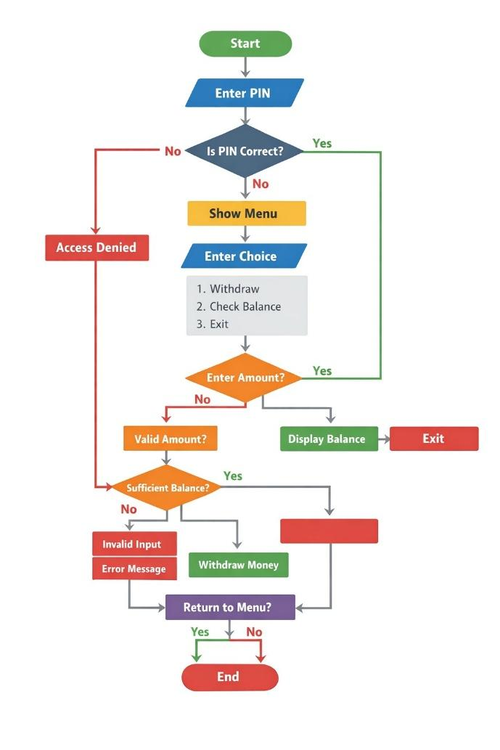

Implementation
1. Account Class
This class is responsible for handling all account-related operations.
- It contains a private balance variable, ensuring data is secure (Encapsulation).
- The withdraw() method:
  - Checks whether the entered amount is valid (greater than 0).
  - Verifies if the account has sufficient balance.
  - Deducts the amount if conditions are satisfied.
  - Otherwise, it throws an error (like insufficient balance).
- The getBalance() method:
  - Returns the current balance to the user.
This class ensures that balance cannot be accessed directly, only through methods.

2. ATM Class
This class handles user interaction and authentication.
- Contains a static PIN variable shared across all users.
- The authenticate() method:
  - Takes user input for PIN.
  - Compares it with the predefined PIN.
  - Grants or denies access accordingly.
- The menu system (loop):
  - Displays options like Withdraw, Check Balance, Exit.
  - Continues running until the user selects Exit.
- It also handles exception cases like:
  - Wrong input (non-numeric)
  - Invalid choices
This class acts as the controller of the system.

3. Main Class
This is the entry point of the program.
- Creates objects of ATM and Account classes.
- Calls the authentication method.
- If authentication is successful:
  - Displays menu repeatedly.
  - Calls appropriate methods based on user choice.
- Ensures the complete flow of the program.
This class connects all components together.

SAMPLE INPUT / OUTPUT (You can type this in your file)
Normal Case
Enter PIN: 1234
1. Withdraw
2. Check Balance
3. Exit
Enter choice: 1
Enter amount: 500
Transaction successful
Enter choice: 2
Balance: 1500
Enter choice: 3
Thank you for using ATM

Error Case (Wrong PIN)
Enter PIN: 1111
Access Denied

Error Case (Insufficient Balance)
Enter choice: 1
Enter amount: 5000
Error: Insufficient balance

Error Case (Invalid Input)
Enter choice: 5
Invalid choice, try again

FUTURE ENHANCEMENTS
You can write these points:
1. Multiple User Accounts
- Add support for different users with different PINs and balances.
2. Deposit Function
- Allow users to deposit money into their account.
3. Mini Statement
- Show last few transactions.
4. Database Integration
- Store account details in a database instead of temporary variables.
5. GUI Interface
- Replace console with a graphical interface using Java Swing or JavaFX.
6. Security Improvements
- Limit number of PIN attempts.
- Add OTP verification.
7. Card Simulation
- Simulate ATM card insertion before PIN entry

Gantt Chart
- Planning & Structure
A Gantt chart helps you break the project into tasks (design, coding, testing, etc.) and set timelines. Even if it's already built once, rebuilding or modifying still needs planning.

Time Management
It shows:
When each task starts When it should finish
This helps avoid delays and last-minute panic.

Conclusion

The ATM Simulation project successfully demonstrates the practical implementation of Object-Oriented Programming concepts in Java. Through this project, important principles such as classes and objects, encapsulation, static variables, and exception handling have been effectively applied.

The system provides a simple and functional interface for performing basic banking operations like withdrawal and balance checking. It also ensures secure access through PIN authentication and handles errors efficiently, making the program reliable and user-friendly.

Overall, this project helps in understanding how real-world systems like ATMs are designed using structured programming and OOP concepts. It also enhances problem-solving skills and provides a strong foundation for developing more advanced applications in the future.

References Book
[1] H. Schildt, Java: The Complete Reference, 11th ed. New York: McGraw-Hill, 2018.
[2] E. Balagurusamy, Programming with Java, 6th ed. New Delhi: McGraw-Hill Education, 2019.

Website
[3] Oracle, "Java Documentation," Oracle. [Online]. Available: https://docs.oracle.com
[4] GeeksforGeeks, "Object-Oriented Programming in Java," GeeksforGeeks. [Online]. Available: https://www.geeksforgeeks.org
[5] W3Schools, "Java Tutorial," W3Schools. [Online]. Available: https://www.w3schools.com/java/

Conference Paper
[6] S. Kumar, "AI in Education," in Proc. IEEE Conf. on AI, 2021, pp. 120-125.

Journal Article
[7] A. Sharma and R. Gupta, "Machine Learning Techniques," International Journal of AI, vol. 5, no. 2, pp. 45-50, 2020.

